Compressed Air Energy Storage (CAES)

Cost effective, safe and efficient energy storage is the missing link in Australia’s power generation infrastructure. In the renewable domain, opportunities for solar energy conversion systems abound (as both wind and photovoltaic) but their inherent diurnal, seasonal or intermittent availability compromises their usefulness in matching peak demand and being scaled up to provide base load.

Accessible, efficient energy storage could transform intermittent, renewable energy sources into a stable commodity with the capacity to be dispatched according to load and market price. Congestion could be controlled and pressure on transmission infrastructure relieved. Such regulatory benefits could even allow the massive capacity of coal fired power stations to be scaled down rather than being sized to provide maximum loads and always on.

One feasible storage option is compressed air. Air is abundant, renewable, economical, transportable, safe and non-polluting. To understand the viability of compressed air, it is important to understand both the process of compression and expansion as well as the constraints of containment. Each component of this secondary process can be considered separately as a component of a hybrid system.

Anatomy of CAES
CAES technology has been in use for 30 years. A CAES plant stores electrical energy in the form of air pressure, then recovers this energy as an input for future power generation. CAES plants can be divided into the following proven components:

- Power system: turbine(s), generator and the recuperator or selective catalytic reduction (SCR) unit.
- Compression system: complete with coolers.
- Containment vessel (or cavern) with airflow piping
- Control equipment: switchgear, substation, cooling system etc.

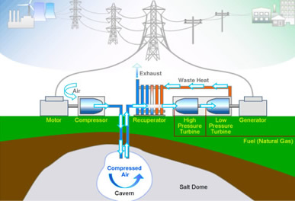
Figure 1. Schematic for underground CAES

In essence, the CAES cycle is a variation of a standard gas turbine generation cycle. In a typical gas fired generation cycle, the turbine is physically connected to an air compressor. When gas is combusted in the turbine, approximately two-thirds of the turbine’s energy goes back into air compression.

In a CAES plant, the compression cycle is separated from the combustion and generation cycle. Off-peak or excess electricity is used to pre-compress air, which is then held for storage, typically in an underground cavern.

When the CAES plant regenerates the power, the compressed air is released from the cavern and heated through a recuperator before being mixed with fuel (e.g. natural gas) and expanded through a turbine to generate electricity. Because the turbine’s output no longer needs to be used to drive an air compressor, the turbine can generate almost three times as much electricity as the same size turbine in a simple cycle configuration. This uses far less fuel per MWh produced. The stored compressed air takes the place of gas that would otherwise have been burned in the generation cycle and used for compression power.

The physics of compressed air
Pascal (1623-1662) was the first to express the notion of pressure:

Pressure in a confined fluid (and gas) is transmitted equally and undiminished in all directions. Pressure (P) = Force(F) per unit Area(A).

P = F/A conversely F = PxA
Boyle (1627-1691) proposed that the product of the pressure and the volume within a closed system would be constant (PV=k). That within a closed system, the pressure of a gas would vary inversely with volume. Increase the volume, and the pressure drops. Decrease the volume and the pressure rises. Boyle’s law provides a useful tool for predicting the behaviour of a pneumatic system.
P₁.V₁ = P₂.V₂
Jacques Charles (1746-1823) concluded that pressure was proportional to temperature. Pressure = Temperature x K (a constant)
P = Tk
Avogadro (1776-1856) found that equal volumes of different gases at the same temperature and pressure contain equal number of molecules. Avogadro’s Number 6.022 x 10²³ refers to the number of molecules of a gas at standard temperature and pressure. A molar volume is always 22.4 litres. With this information it is possible to find the weight of any quantity of any gas whose molecular formula is known.
These discoveries contributed to the development of what is known as the Ideal Gas Equation. This was formulated by Clapeyron (1799-1864). It describes the relationship between pressure, temperature and volume.
PV = RT
where
P is the absolute pressure of the gas,
V is the volume of the gas,
is the number of moles of gas,
R is the universal gas constant,
T is the absolute temperature.

However, real gases deviate from Ideal Gas Behaviour but usually the deviations are so slight that they can be neglected.

Compressed air is normally used in pressure ranges from 1 to 414 bar (14 to 6004 PSI) at various flow rates from as little as 0.1m³ (3.5 CFM - cubic feet per minute) and up.
There are two theoretical relationships between temperature and pressure in a volume of gas undergoing compression. Neither of them model the real world exactly but each can be useful for understanding the inherent constraints of the process. A third method, measures real-world results:
- Isothermal compression
Assumes that the compressed gas remains at a constant temperature throughout the compression or expansion process. In this cycle, internal energy is removed from the system as heat at the same rate that it is added by the mechanical work of compression. Isothermal compression or expansion more closely models real life when the compressor has a large heat exchanging surface, a small gas volume, or a long time scale. Compressors that employ cooling between compression stages come closest to achieving isothermal compression. However, in the real world, perfect isothermal compression is not attainable.
- Adiabatic compression
Assumes that no energy (heat) is transferred to or from the gas during the compression process and all mechanical work is added to the internal energy of the gas, resulting in increases of temperature and pressure. Conversely, when a gas expands under adiabatic conditions, its pressure and temperature both decrease without the gain or loss of heat. The adiabatic cooling of air as it rises in the atmosphere is the main cause of cloud formation. With Adiabatic storage, the heat that appears during compression is also stored, then returned to the air when the air is expanded. Adiabatic compression or expansion can model real life when a compressor has good insulation, a large gas volume, or a short time scale. In practice there will always be a certain amount of heat flowing out of the compressed gas. A perfect adiabatic compressor would require perfect heat insulation of all parts of the machine.
- Polytropic compression
Assumes that heat may enter or leave the system, and that input work can appear as both increased pressure and increased temperature above adiabatic (usually losses due to cycle efficiency). This accounts for both a rise in temperature in the gas as well as some loss of energy (heat) to the compressor's components. Compression efficiency is then the ratio of temperature rise at theoretical 100 percent (adiabatic) vs. actual (polytropic).

Types of compressors:

Piston Compressor
The piston compressor is one of the earliest compressor designs and remains the most versatile and efficient. A piston moves forward in a cylinder via a connecting rod and crankshaft. If only one side of the piston is used for compression, it is described as single acting. If both sides of the piston, top and underside are employed, it is double acting.
The piston compressor is the only design capable of compressing air and gas to high pressures, such as breathing air applications. The configuration of a piston compressor can be a single cylinder for low pressure/low volume to a multi-stage configuration cable of compressing to very high pressure. In these compressors, air is compressed in stages, increasing the pressure before entering into the next stage to compress the air to even higher pressure.
Typically such pistons operate between 0.75 kW to 420 kW (1hp to 563hp) producing working pressure at 1.5 bar to 414 bar (21 to 6004psi). They are used for Gas compression (CNG, Nitrogen, Inert gas, Landfill gas), High Pressure (Breathing air for SCUBA SCBA cylinders, Seismic surveying, Air blast circuit), P.E.T bottling, Engine starts and Industrial applications.

Rotary Screw
The screw compressor is a displacement compressor with pistons in a screw format; this is the predominant compressor type in use today. The screw compression element have male and female rotors that move towards each other while the volume between them and the housing decreases. The pressure ratio of a screw is dependent on the length and profile of the screw and of the form of the discharge port.
The screw element is not equipped with any valves and there are no mechanical forces to create any imbalance. It can therefore work at high shaft speed and combine a large flow rate with small exterior dimensions.
Typically such pistons operate between 4kw to 250 kW (5 to 535hp), producing working pressure at 5 bar to 13 bar (72 to 188psi). They are used for Food Beverage, Brewing, Military, Aerospace, Automotive, Industrial, Electronic, Manufacturing, Petrochemical, Medical, Hospital, Pharmaceutical and Instrument air.

Rotary Vane
The vane compressor is directly driven at very low speed (1450rpm), offering unrivalled reliability. The rotor, the only continually moving part, has a number of slots machined along its length into which fit sliding vanes that ride on a film of oil.
The rotor rotates within a cylindrical stator. During rotation, centrifugal force extends the vanes from their slots, forming individual compression cells. Rotation decreases the cell volume, increasing the air pressure. The heat generated by compression is controlled by pressurised oil injection. High-pressure air is discharged through the outlet port with the remaining traces of oil removed by an oil separator.
Typically such pistons operate between 1.1 kW to 75 kW (1.5 to 100hp), producing working pressures of 7 to 8 and 10 bar (101 to 145psi). They are used for OEM, Printing, Pneumatics, Laboratories, Dentistry, Instruments, Machine tools, Packaging and Robotics.

Underground storage
The volume of air storage required for a typical CAES plant is most economically provided by geological structures. Impermeable underground caverns have proven to be both technically and economically feasible for storing gases and liquids for over 40 years.
Use of other storage types such as hard rock mines or aquifers may expand the geographic location of CAES plants throughout North America, to the United Kingdom, Continental Europe, and the Middle East.
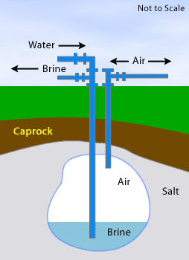
Figure 2. Schematic for creating underground storage caverns
The use of salt caverns for the underground storage of gases and liquids is thoroughly understood and in common use. The caverns are created by drilling a conventional well where fresh water is pumped into a salt dome or bedded salt formation. The salt dissolves until the water is saturated, and the resulting salt water is returned to the surface as brine. This process continues until a cavern of the desired volume and shape is created.

Economics of CAES
Compressed air energy storage is the only other commercially available technology
(besides pumped-hydro) able to provide the very-large system energy storage
deliverability (above 100MW in single unit sizes). Since CAES facilities have no need for air compressors tied to the turbines, they can produce two to three times as much power as conventional gas turbines for the same amount of fuel.

The business proposition for compressed air storage derives from the savings from mitigating external costs associated with production, such as transmission or integration costs; and the benefit from making the power worth more, such as by adding capacity value or by shaping the power flow over time to meet peaking requirements.

Capacity value can be thought of as the value of being able to guarantee that megawatts can be made available to serve peak load for long-term planning purposes, and megawatts of capacity can therefore replace/defer the construction of the next physical generation asset. Firming value is the value of being able to guarantee the provision of energy, ancillary services, and short-term capacity such that better commitment decisions can be made.

The functional separation of the compression cycle from the combustion cycle provides a CAES plant with many advantages compared to simple cycle (SC) and combined cycle (CC) natural gas power plants. These features translate into significant benefits for wholesale electricity traders, buyers and sellers of full requirements power, and electric utilities.

It doesn’t matter whether the energy is coming from a renewable conversion system, from storage, or from both. The important factor is the net energy delivered to the grid.

Due to economies of scale, a smaller CAES plant would be unlikely to demonstrate economic viability, since the capital costs per kW would be disproportionately high. Some studies have suggested that a 270 MW CAES plant coupled with 500 MW of wind would be a commercial proposition.

Three CAES Case Studies

1. The first CAES plant, 290 MW, commissioned in 1978, Huntorf, Germany
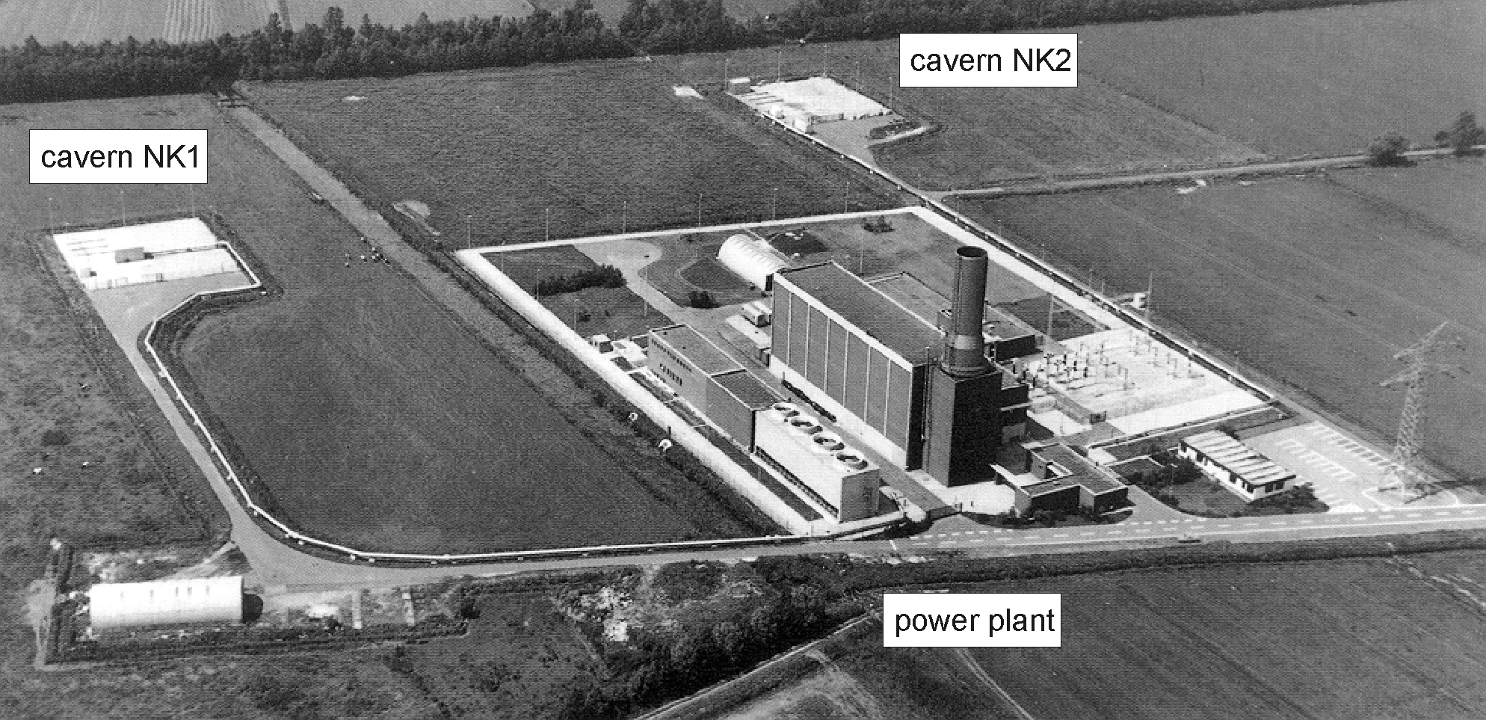

Figure 2. Aerial photograph of E.N Kraftwerke’s CAES plant in Huntorf, Germany
E.N Kraftwerke’s CAES plant was built as a response to the growing capacity of wind power in Germany and the growing importance of the ‘minute reserve.’ The minute reserve refers to power station output that can be made available within a few minutes. Since it was first commissioned, the plant has been extended with a 300,000 m3 natural gas cavern to supply the gas turbines with higher economic efficiency.
output  - turbine operation  - compressor operation | 290 MW (< 3 hrs)  60 MW (< 12 hrs)
air flow rates  - turbine operation  - compressor operation  - air mass flow ratio in/out | 417 kg/s  108 kg/s  1/4
number of air caverns | 2
air cavern volumes (single)  total cavern volume | ~140 000 m³  ~ 170 000 m³  ~ 310 000 m³
cavern location  - top  - bottom | ~650 m  ~ 800 m
maximum diameter | ~ 60m
well spacing | 220m
cavern pressures  - minimum permissible  - minimum operational (exceptional)  - minimum operational (regular)  - maximum permissible & operational | 1 bar  20 bar  43 bar  70 bar
maximum pressure reduction rate | 15 bar/h
Table 1. E.N Kraftwerke’s CAES plant specifications

General design

The total volume of about 310,000 m3 was sized to the specified operating pressures and the stored air mass in relation to the thermodynamic effects in the cavern during injection and withdrawal. Although the total volume could have been realised with a single cavern, two were commissioned because of:

- Redundancy during maintenance, cavern shut-down
- Easier cavern refilling after drawing down the pressure in a cavern to atmospheric pressure.
- Start up procedure for plant compressor requires a minimum pressure of 13 bar in at least one of the caverns.

The depth of the caverns was designed to ensure stability for several months at atmospheric internal pressure, as well as to guarantee the specified maximum pressure of 100 bar. Both are subject to extremely high withdrawal rates of 417 kg/s combined with low-pressure losses. This required a 20”/21" production string with a 24 1/2" final casing. Because of the absence of a packer to fix the production string in the final casing, there was a danger that the final casing could be corroded. The moist air was a very corrosive medium. To reduce costs, the production string was initially made out of normal structural steel with extra thick walls. The spirally welded production strings with welded joints hung about 80m in the cavern without support. This was to prevent the entry of salt dust via the cavern throat into the turbines and was counteracted by the injection of dry air.

Brine in the caverns was withdrawn using a submersible pump because the plant compressor had an inadequate maximum pressure and an excessively high air flow rate resulting in unacceptable air velocities in the production string.

Operational experience

The start up procedure for the plant compressor requires a minimum pressure of 13 bar in the cavern. This was achieved by partially filling the cavern from its neighboring cavern. The number of starts made by the plant has fluctuated widely during its operation. This was attributable to

- connection to a larger network in 1985 which added pumped hydro capacity
- the CAES plant's primary role as an emergency reserve in case of unplanned failure of other power plants
- the CAES plant's role as an alternative option to purchasing expensive peak load from outside suppliers.

The power station is now typically used as a minute reserve for medium load coal power stations. These take 3 – 4 hours to generate full capacity before they can provide short-term power – the intervening time is preferentially covered by CAES plant.

Another typical use was for peak shaving in the evening, when no more pumped hydro capacity was available. An additional application is associated with the strong increase in the number of wind power plants in North Germany in recent years. The availability of this type of power cannot be reliably forecast and the plant in Huntorf was able to quickly compensate for any unexpected shortage in wind power.

Thermodynamics

During first-fill and later trial runs, extensive measurements of pressure and temperature were carried out. The subsequent numerical simulation of the thermodynamic behavior revealed that the heat exchange with the rock only took place in a peripheral zone about 1 metre thick. The irregular shape of the caverns had the advantage of increasing the heat exchange between the air and the cavern walls, which in turn led to a significant increase in storage capacity. When the air is expanded to atmospheric pressure, the pressure drop initially results in the expected cooling of the air, but after reaching a minimum, the temperature rises again.

Maintenance

Surveying the contours of the caverns proved to be difficult because the usual ultrasonic tools used in gas caverns have an inadequate and are sensitive to the humidity of the compressed air. Regular laser surveys carried out as an alternative were ineffective because of the fog in the cavern and the condensation of moisture on the lens. When cavern NK1 was expanded to atmospheric pressure at the beginning of 2001, a survey was possible with a heated laser tool. The evaluation of this survey after over 20 years of operation showed practically no deviation compared to the original conditions.

After only a few months of operation, serious corrosion problems became apparent with the high levels of rust in the filter upstream of the gas turbine. This caused shutdowns shortly after the start up of the power station.

Fiberglass reinforced plastic was selected as a replacement at the beginning of the 80s for reasons of costs and ease of installation. Material problems are now occurring in some of the pipe sections resulting in partial destruction of the FRP strings.

2. 110 MW CAES, commissioned in 1991, McIntosh, Alabama, USA
A 110 MW CAES system was declared commercial in McIntosh, Alabama on May 31, 1991. The system uses an underground cavern to store compressed air. The storage space was formed by pumping water in and out of it in order to dissolve salt and form the cavern (see Figure 2). The cavern is 220 feet in diameter and 1000 feet deep, for a total volume of 10 million cubic feet. At full charge, this cavern is pressurized to 1100 psi. It is discharged down to 650 psi. During discharge, 340 pounds of air flows out of the cavern each second. The cavern can discharge for 26 hours.
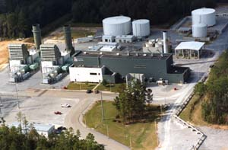
Figure 3. Aerial photograph of CAES plant in McIntosh, Alabama, USA
The compressed air feeds a 100MW gas-fired combustion turbine. Compared to conventional combustion turbines, the CAES-fed system can start up in 15 minutes rather than 30 minutes, uses only 30% to 40% of the natural gas, and operates efficiently down to low loads (about 25% of full load).
The McIntosh plant made improvements to the Huntorf design by incorporating a recuperator (air to air heat exchanger) to preheat air from the cavern with waste heat from the turbines. Since overcoming some start-up issues, the plant has functioned with over 95% reliability. The successful operation of the McIntosh and Huntorf plants has demonstrated the technical viability of CAES technology in supplying ancillary services, load following, and intermediate power generation.

3. Moteur Development International (MDI)
MDI is a mercurial French company setting up in Melbourne that makes a range of extravagant claims that test their credibility. It argues the case for what it calls ‘net energy’. MDI has proposed an integrated solar infrastructure based on networking small scale vehicular and domestic CAES systems.
MDI claims to have developed three core technologies that are capable of enabling full solar energy economy:

- An advanced wireless broadband Network (FraMe )

This is claimed to enable the networking of new energy technologies in a distributed fashion to harvest and distribute solar energy over wide areas. It is not clear how this would work but MDI claims that their FraMe Network will enable multiple uses, where the one infrastructure provides services currently delivered by parallel communication infrastructures. MDI estimates that it can cut current Network costs by a factor of ten.

2. An Intelligent Power Network (iPower)

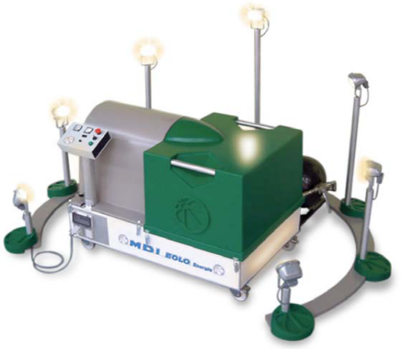

Figure 4. MDI’s CAES Intelligent Power Network (iPower)

This is based on an engine that runs on compressed air. The primary energy input takes place outside the engine, in an external heating unit at significantly lower temperatures than in an internal combustion engine. It is proposed that this engine be used in a stationary way to produce electricity. The commercial units are planned to range from 6KW – >MW. MDI expects the domestic units to be the size of a small suitcase, or an air conditioning unit. The unit can be used stand alone, for example on a farm, or as an emergency back up in an office building, or integrated to the grid and managed and regulated through MDI’s broadband FraMe networks. The company claims a current power charge of 6 cents p/kWhour, falling to 4 cents and then 2 cents in 3 years.

- The MDI zero (or near zero) emission vehicles

The same engine is proposed for what MDI calls CATs (Compressed Air Transport). MDI claims a fuel consumption of 2litres/100 km with this falling to 1litre/1000km. MDI also claims to have a manufacturing agreement with Tata Motors in India and estimates that the cars will retail for AU$8,000.00.

However, there is little evidence of such an agreement on the Tata website and there are numerous reports [online] that the claims made by MDI may not stand up to close scrutiny.

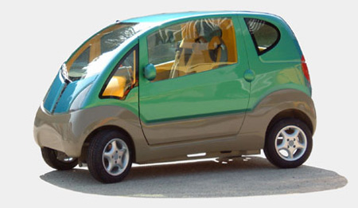
Figure 5. MDI’s CAES CAT mini car

Ultimately, it is proposed that these vehicles will be networked and managed with the MDI’s FraMe networks.

CAES future and viability
Despite its success from a technological standpoint, there appears to be little current CAES activity in Europe. Reports suggest that there is more concern about dwindling natural gas supplies and the need to save energy than there is to store it.
A recent initiative (backed by the U.S. Department of Energy) by a group of municipal utilities in Iowa and surrounding states is developing a new energy park that would integrate a 75-150 megawatt wind farm with CAES technology. The Iowa project is expected to cost $200 million and operate by 2011 with the capacity to store 200 megawatts of power, enough for several days.
Nevertheless, CAES has not been widely deployed in the USA. A 2005 report on the economic impact of CAES suggests the following reasons:
1. Since regulated utilities grew through an increase in invested capital, there was no economic incentive to add CAES, which increases the efficiency of existing plants and decreases the total capital required to serve a given load;
2. Independent power producers in the US did not develop CAES because CAES did not qualify for Public Utility Regulatory Policies Act (PURPA) contracts, which were available only for renewable power plants or for cogeneration facilities.
3. There was a boom in power plant construction in the late 1990's, but a lack of available equipment prevented the development of new CAES plants. Until very recently, major turbine manufacturers had sold out production capacity and had not been willing to invest in the development of CAES turbines.
In spite of its extravagant claims, the MDI case study indicates that CAES is re-surfacing as a component of broader infrastructures. There are other smaller scale CAES systems appearing.
Overall, it seems curious that there are no CAES initiatives in Australia where there is abundant natural gas and a variety of potential storage caverns.
“CAES is probably the most viable, large-scale energy storage potential on the market right now," Garth Corey (electrical storage consultant and former Sandia National Labs scientist).

References:
Arnoux, L. IT MDI Submission to The Australian House of Representatives
Industry and Resources Committee (undated)
[Available on-line]
http://www.itmdi-energy.com/information/applications.html

Compair: Animations of 3 kinds of compressors
[Available on-line]
http://www.compair.com/About_Us/Compressed_Air_Explained--03The_three_types_of_compressors.aspx

Crotogino, Mohmeyer and Scharf Huntorf. CAES: More than 20 Years of Successful
Operation 2001
[Available on-line]
http://www.uni-saarland.de/fak7/fze/AKE_Archiv/AKE2003H/AKE2003H_Vortraege/AKE2003H03c_Crotogino_ea_HuntorfCAES_CompressedAirEnergyStorage.pdf

EUREC Agency. FP7 Research Priorities for the Renewable Energy Sector Consolidated Input 2005
from European Renewable Energy Research and Industry to the European Commission Stakeholder Consultation on Research Themes of the 7th Research and Development Framework Programme

Iowa Stored Energy Park
[Available on-line]
http://www.isepa.com/about_isep.asp

LaMonica, M. Storing sun and wind power Green Tech 2007
[Available on-line]
http://www.news.com/Storing-sun-and-wind-power/2100-13840_3-6221396.html

Lerch, E. Energy Storage to Balance Wind Power Fluctuations ACTA Press Proceedings: Asian Power and Energy Systems - 2007
[Available on-line]
http://www.actapress.com/PaperInfo.aspxPaperID=30255&reason=500

Ridge Energy Storage
[Available on-line]
http://www.ridgeenergystorage.com/

Ridge Energy The Economic Impact of CAES on Wind in TX, OK, and NM
Final Report for Texas State Energy Conservation Office 2005
[Available on-line]
http://www.ridgeenergystorage.com/caes_addinfo.htm

Webb, R. An Electricity Savings Account Hart. 2001
[Available on-line]
http://www.ridgeenergystorage.com/AnElecSavingsAcct_vs2.pdf

